Tomato Grow Bags

Botanicoir Dry has been designed to encourage generative growing in crops that need a drier substrate to promote healthy growth.
This slab has a very high air-fill porosity and gives the grower the ability to steer the crops as they see fit.
A mix of more husk chips, but still with smaller particles to help the younger plants take to the bag,
Botanicoir Dry is the optimum environment for crops needing exceptionally high drainage.
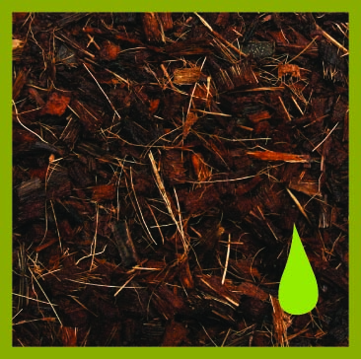
We make each product specifically to the growers needs, from the coir mix to the plastic for the bag.
Salad grow bags are available in sizes up to 120cm in length with width and height as required, and planting, dripper and drainage holes can pre-cut in the bags to the growers requirements, at no extra cost.
All of the plastic that we use is high quality, UV treated and recyclable.

Tomato Grow Bags
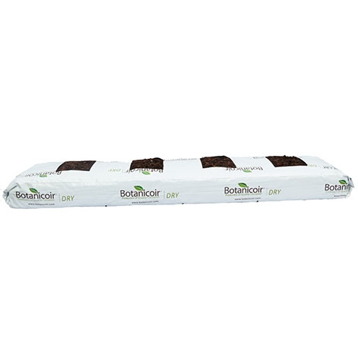

2 or 4 Holes
+ Drainage Holes & Dripper Holes
100 x 20 x 8cm
500 Units per Pallet

